**SD03Q011 – Problem Statement 2**

Balamanikandan V

1832012

**Problem Statement:**

Try to understand the dataset of Social_Network_Ads.csv and try to find the best suitable ML algorithm and write the code in python for algorithm from scratch and try to achieve the below output plot.



**Dataset:**

Given a data set (Social_Network_Ads.xlsx) which consists of 5 columns and 400 rows.

**Algorithm used:**

Gaussian Naïve Bayes Classifier

**Why Gaussian Naïve bayes Algorithm**

Naive Bayes uses the Bayes’ Theorem and assumes that all predictors are independent. In other words, this classifier assumes that the presence of one particular feature in a class doesn’t affect the presence of another one. Faster than other algorithms.

**Output plot - Training Set**

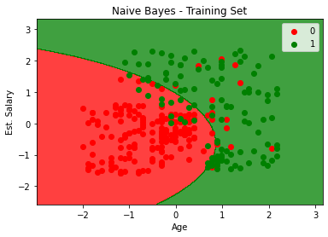

**Output plot – Test Set**

